**User Manual**

**Running the Program**

After the project has been successfully installed on your machine, click the **Start** button (or press F5) to run the program.

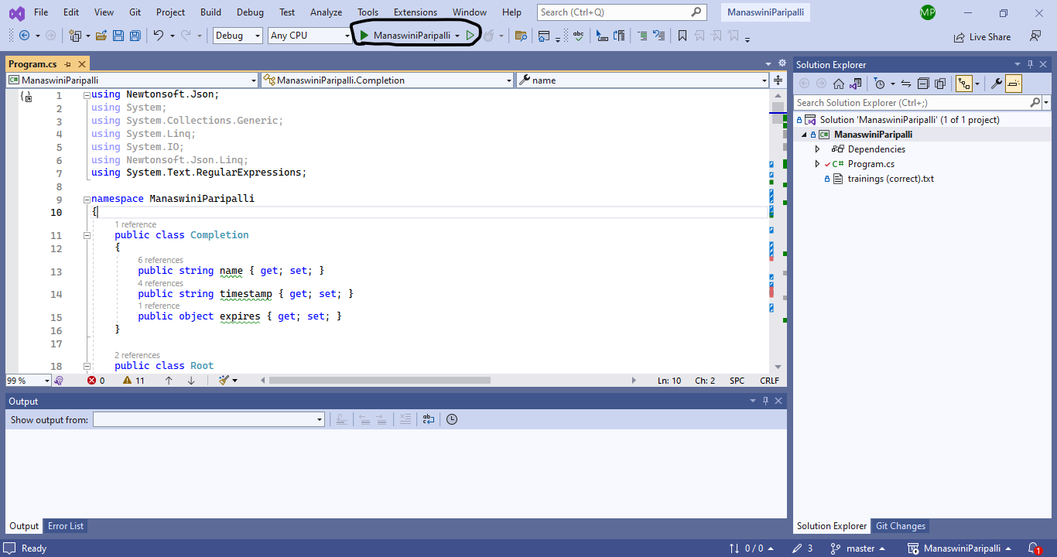

The console will display the output in the following format, showing the calculated results and user prompts.

**Task 1:**

* No input parameters are required for Task 1.
* If the user wishes to modify parameters for Task 2, they can do so.

**Task 2 Instructions:**

* If the user wants to provide an input only for the year and continue with the default training names list, they can press Enter after entering the year.
* To use the default year (2024), press Enter without entering anything.

* If the user wants to modify the training names, they need to input them in the format specified on the screen.

If both the year and the training names need to be changed, the user can do so by providing the appropriate inputs.

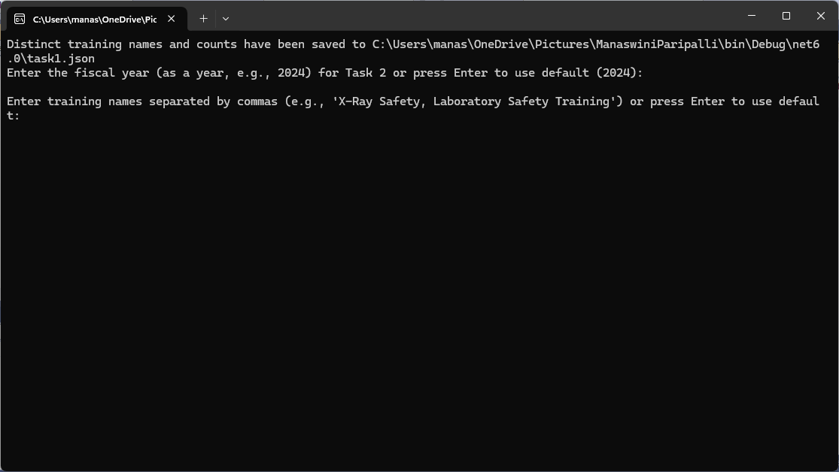

**Task 3 Instructions:**

* The user can specify the **date parameter** in the format displayed on the screen.
* To use the **default date**, press **Enter** without entering any value.

**End of Program**

* This marks the end of the program execution.

**Note:**

* **The generated files can be found at the following location on your computer:  
  your-saved-location/ManaswiniParipalli\bin\Debug\net6.**

**File Details:**

* **Task 1:** The details are saved in the Task1.json file.
* **Task 2:**
  + If the user provides any inputs for Task 2, the data is saved in the task2overwritten.json file.
  + If no input is provided, the data is saved in the Task2.json file.
* **Task 3:**
  + If the user provides inputs, the file is saved as task3overwritten.json.
  + If no input is provided, it is saved in the Task3.json file.